**CSE211 Web programming, Fall Semester 24/25**

**Assignment #1: Websites conceptual Design and mock-up**

**Lougine Abdelazim Mohamed 222101234**

**Research**

1. **Characteristics of Web 2.0, Web 3.0, and Web 4.0**

Web 2.0 is all about a participatory web, websites that emphasize user-generated content, ease of use, and participatory culture. This era was marked as the rise of social media due to the interacting and collaborating features that were added e.g., sharing, as well as allowing users to share in real time life updates.

Web 3.0 the semantic and decentralized web, which is used for enhancing security, also has AI and ML which allows the web to interpret user intent more accurately, providing more relevant and personalized content.

Web 4.0 symbiotic web, which heavily depends on AI where it can comprehend our own ideas and successfully browse the web, the IOT enables devices to communicate and interact making the web more embedded in daily life.

Each successive generation builds upon the last, increasing in user engagement, machine intelligence, and integration with other technologies, and setting the next web users for a much more interactive, intelligent, and decentralized web.

1. **Key Features of Web 2.0 and Network Empowerment**

The well-known and leading feature is the user’s ability to make content, and share it which strengthens networks and broadening it, this is also known as user-generated content, real time updates, as well as tagging also kept the web (social media platforms) alive and livelier than before. Web 2.0 empowers networks by amplifying user interaction and collaboration, increasing the value as more users join and engage.

1. **Key Features of Web 3.0 and Knowledge Empowerment**

Web 3.0 leverages blockchain decentralization technologies to distribute data across a network, eliminating reliance on centralized entities. This empowers users by giving them control over their own information. Also, ownership allows users to own their identities and data, allowing them to make their own choices about what is to be shared.

1. **Key features of Web 4.0 and Intelligence Empowerment**

Advanced AI systems provide personalization in understanding the needs and preferences of the users. They also succeeded in making machines collaborate with humans, provide real-time answers, and improve decision-making. Such features foster intelligent connections and create a more interactive and responsive digital environment, allowing users to dive deep into technology and into each other, which gives way to better collaboration and knowledge sharing.

1. **The Role of Collective Intelligence, Social Networking, social media, and social bookmarking**

Collective Intelligence: Enhances problem-solving and creativity by pooling diverse knowledge and perspectives, fostering interactive learning environments. Social Networking: Promotes collaboration and engagement, helping individuals connect and share ideas, which supports peer learning and community building. Social media: Serves as a powerful communication tool, allowing organizations to reach broader audiences, engage in real-time, and gather feedback to improve educational content. Social Bookmarking: Facilitates resource sharing and discovery, enabling users to curate and access relevant educational materials collaboratively.

1. **Empowering Current and Future Business Plans**

Enhanced Collaboration: Fosters a culture of teamwork, leading to innovative solutions. Increased Engagement: Direct interaction with customers through social media boosts brand loyalty and awareness. Data-Driven Decisions: Insights from social media analytics help tailor offerings to customer preferences. Scalability and Reach: Digital tools enable businesses to access global markets. Resource Sharing: Knowledge sharing enhances workforce adaptability and effectiveness.

1. **Intent to use latest technologies in your profession**

Collective Intelligence: Enhances problem-solving and creativity through the collection of diverse knowledge and perspectives, nurturing interactive learning environments. Social Networking: It encourages collaboration and engagement; helps people connect and share ideas, supporting peer learning and community building. Social media: This most powerful communication tool can be molded by any organization to reach wider audiences, engage in real time, and receive feedback toward improving the educational content. Social Bookmarking: Permits sharing and finding of resources—whereby users can curate and access relevant educational materials collaboratively.

**Website planning**

### **1. Define the purpose of your intended website.**

The online art gallery focuses on showing diverse artworks from different artists to promote art appreciation and provide them with a selling platform.

### **2. What would you like the website to accomplish?**

The website is for the promotion of artworks, for artists to get exposure and sales, and to draw in the community of art lovers.

### **3. Who is your intended audience?**

Its readership comprises art collectors, emerging and established artists, and students interested in art.

### **4. What opportunities, problems, or issues does your planned website address?**

It offers artists broader exposure and accessibility to art, while helping them overcome sales challenges associated with traditional galleries.

### **5. What kind of content could be incorporated on your website?**

Content may include artwork galleries, artist profiles, blog posts, an e-commerce section, and an events calendar.

### **6. How will the site serve the client?**

The site provides an intuitive interface for browsing and purchasing art, allowing artists to manage their profiles and portfolios.

### **7. What's the best method for the user to do what is wanted?**

Users will benefit from clear navigation, categorized browsing, and a search function to find specific artworks or artists.

### **8. How will users find the function?**

Users will locate functions through a structured menu, search functionality, and clear call-to-action buttons.

### **9. How will the results of the function be received?**

Results will be communicated via confirmation emails and on-screen notifications**.**

### **10. What will the receiver do with the received entries?**

The receiver will review inquiries, process orders, and follow up with users as needed.

### **11. How will the receiver deal with the results?**

Results will be managed through a content management system (CMS), facilitating communication with artists and customer service.

### **12. What follow-up will be needed?**

Follow-ups include sending thank-you emails, requesting feedback, and updating users about new artworks.

### **13. List at least two related or related sites found on the Web. Explain why you chose them.**

1. Saatchi Art: A well-known platform for connecting artists with buyers, offering a wide range of artworks and educational resources.
2. Art finder: Focuses on selling original art directly from artists, known for its user-friendly interface and community engagement features

**14. Prepare the planning analysis sheet that includes the following:**

**a. Website Goal**  
To create an interactive online gallery featuring various artwork, in order to promote artists and make the selling of art easier to a wider audience.

**b. Working Titles of Pages (Excluding Home Page)**

1. About Us
2. Exhibitions
3. Artists
4. Artworks
5. Trending
6. Contact

**c. Page Contents Description**

1. **Home Page**
   * **Content:** featured artworks, slideshow of current exhibits, navigation menu, and links to social media.
   * **Media:** Images of featured artworks
2. **About Us**
   * **Content:** Information about the gallery’s mission, history, and vision.
3. **Exhibitions**

* **Media:** Text, images of past exhibitions

1. **Artists**
   * **Content:** Profiles of featured artists, including their biographies, artistic styles, and links to their artworks.
   * **Media:** images of their artworks
2. **Artworks**
   * **Content:** A gallery displaying the available artworks for sale
   * **Media:** High-quality images of artworks, descriptions, and prices.
3. **Trending**
   * **Content:** Information about popular artworks, current trends in the art world, and featured artist spotlights.
   * **Media:** Text, images.
4. **Contact**
   * **Content:** Contact information for inquiries and support, including a contact form.
   * **Media:** location.

**d. User Forms for Information Collection**   
Users will interact with forms on the website in the following ways:

* **Contact Form:** Users can send inquiries or feedback by filling out a form with fields for their name, email, subject, and message.
* **Event Registration Form:** Registrations to exhibitions are possible by providing contact details and RSVPs to an event.
* **Newsletter Subscription:** Users can even subscribe to a newsletter by providing their email address that will be stored for further communications.
* **Artist Submission Form:** Artists can submit their work through the submission form, which includes all details of the artist, the title of the work, medium, and options to upload images where applicable.

**e. Flowchart**

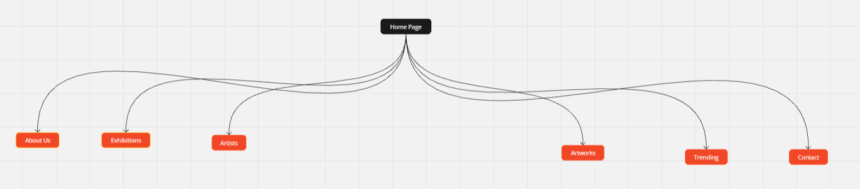

**f. Pages wireframe**

Homepage

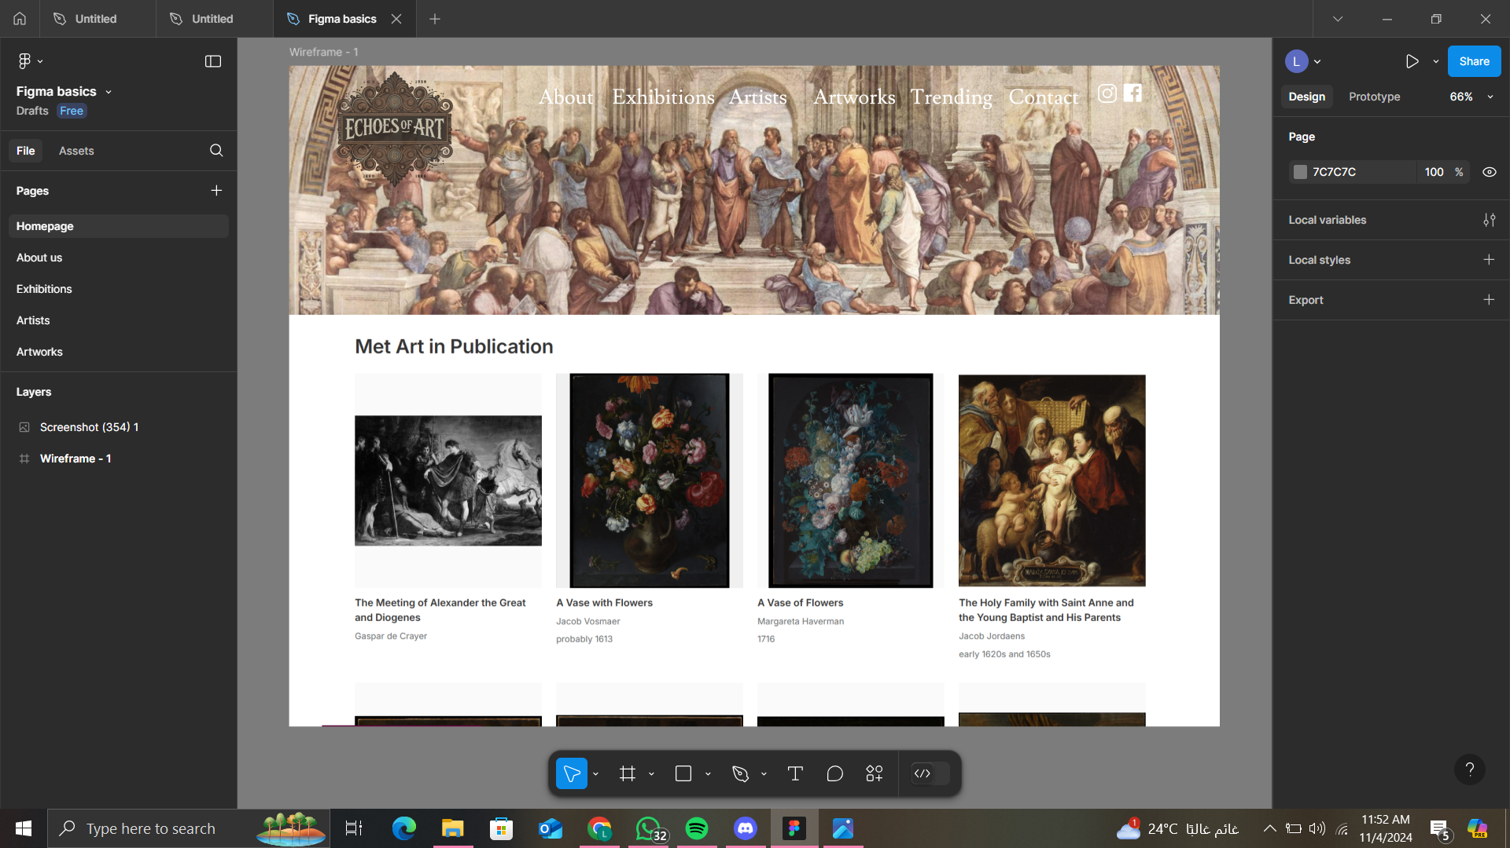

About us

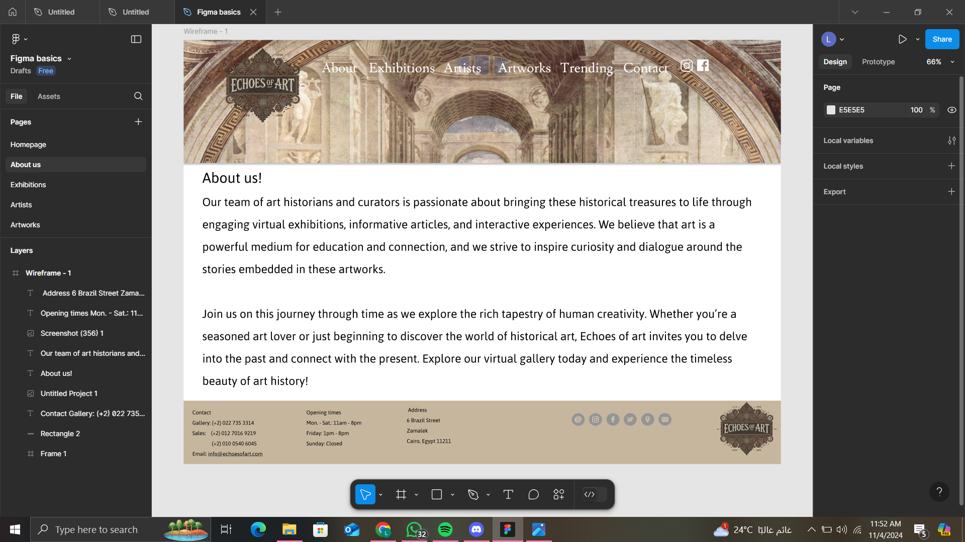

Exhibitions

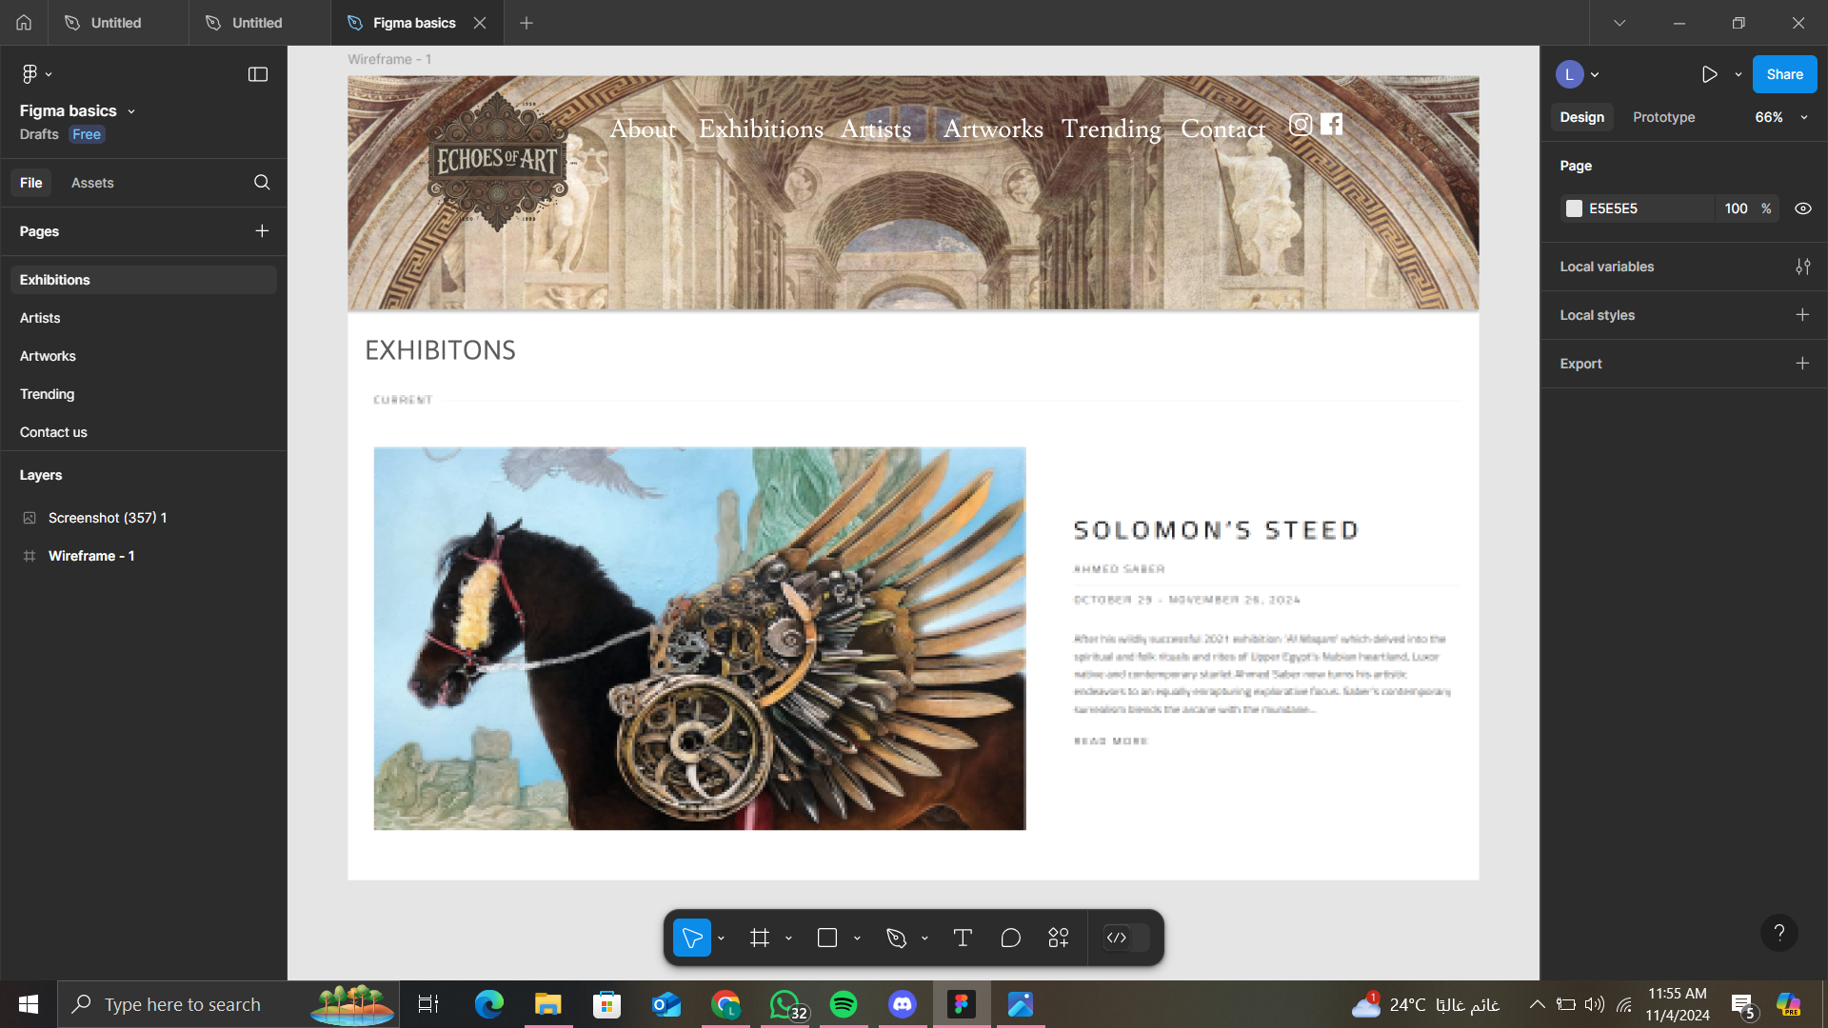

Artists

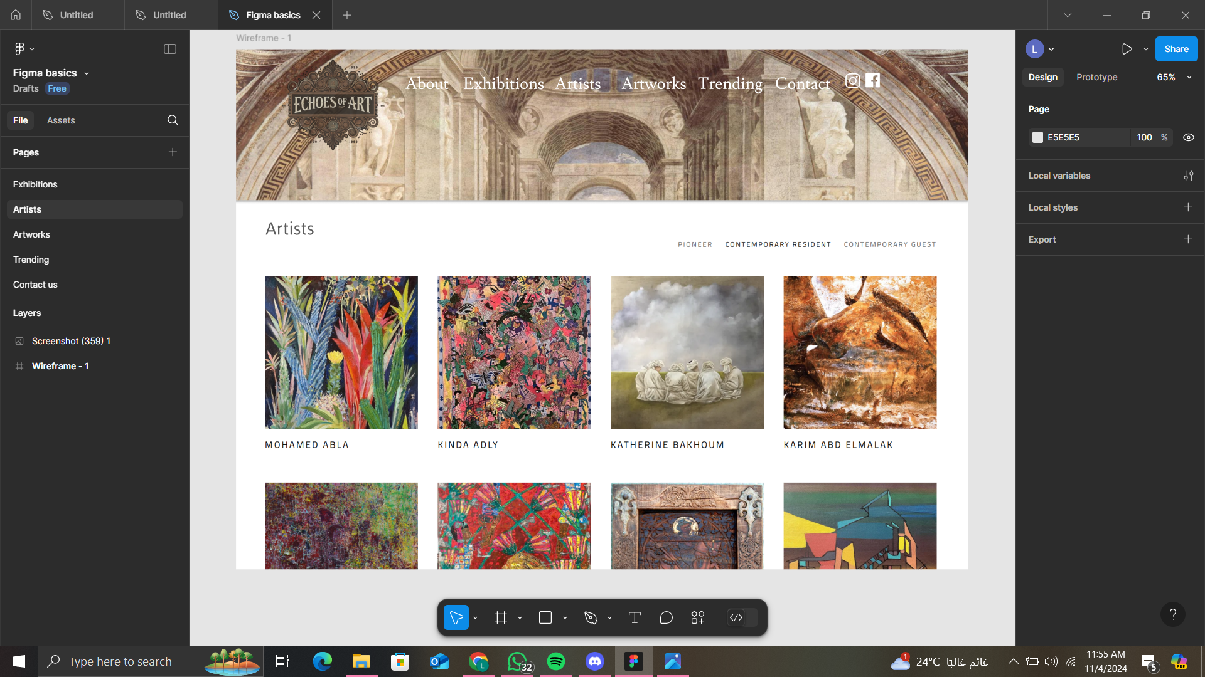

Artworks

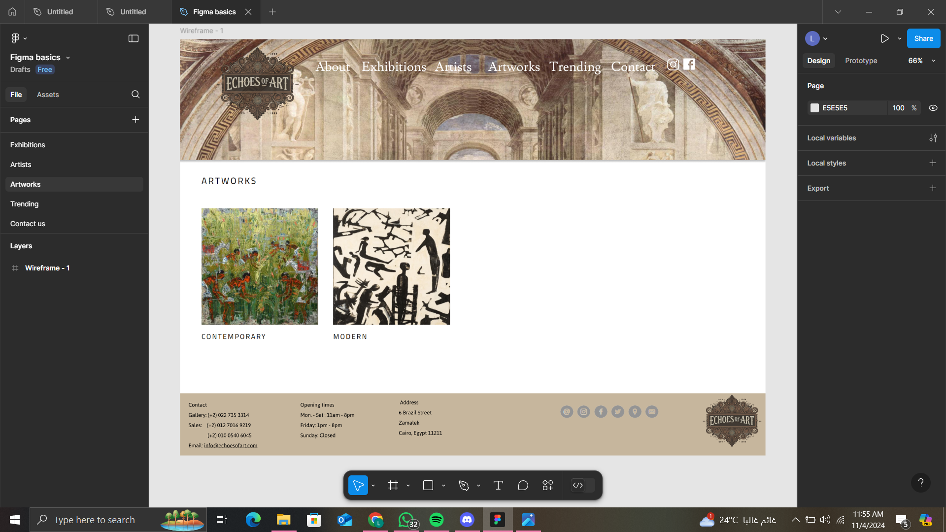

Trending

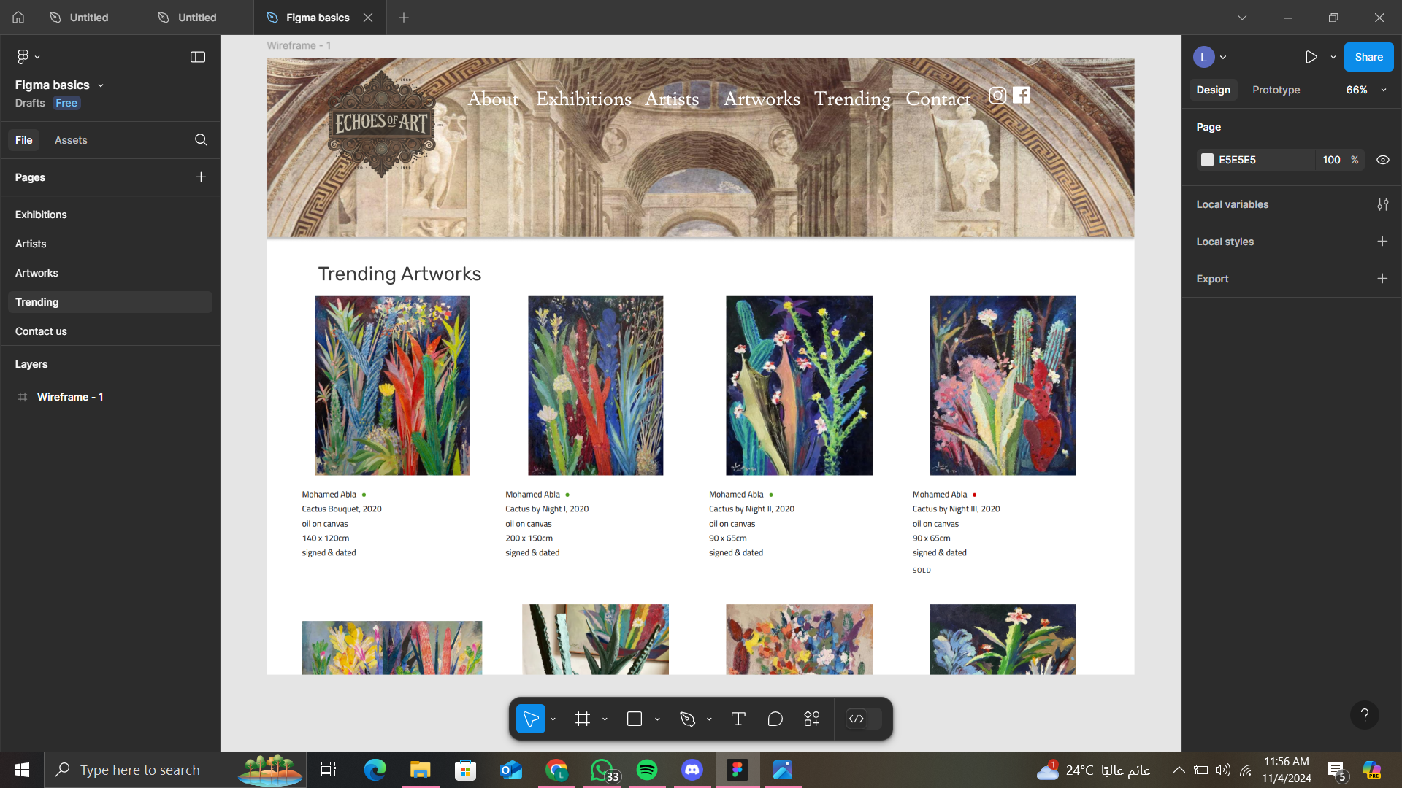

Contact us

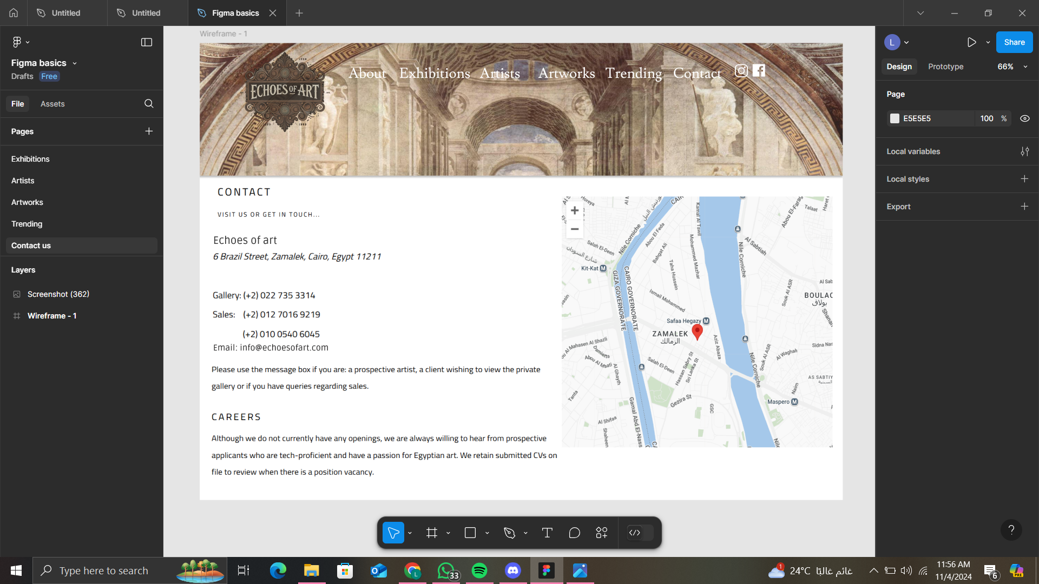

**Website design**

**[A] Use Gestalt Web Design Principles to explain how you will achieve the following within each page of your proposed website:**

**1. Law of PRÄGNANZ (Good Figure, Law of Simplicity)**

* A clean layout with minimal distractions will really let the key elements in your pages, such as artwork images and navigation, stand out. For example, the home page will feature a minimalistic grid display of featured artworks so users will have an idea of what the gallery is offering.

**2. Closure (Link Individual Elements to Form a Pattern)**

* Images of artworks can be laid out in such a way as to suggest a cohesive collection on the Exhibitions page; even if there is not enough artwork to be shown, the layout will visually suggest a full exhibition and therefore entice users to click and view more. 3. Symmetry and Order (Convey Information Quickly and Efficiently) The Artists page will have symmetrical layout of artist's profiles that are evenly spaced apart. An organization such as this allows the user to find information fast but also creates a nice-looking aesthetic to enhance usability.

**3. Symmetry and Order (Effectively Communicate Information Quickly)**

* The Artists page will have a symmetrical layout with artist profiles spaced evenly. The spacing of the profiles is good for finding information and looks good, thereby enhancing usability.

**4. Figure/Ground (Relationship Between Positive Elements and Negative Space)**

* On the Artworks page, artworks will sit on a neutral background so that the images become the focus; adequate white space around each piece will make it more visible and will help to reduce visual clutter.

**5. Uniform Connectedness (Relationship Between the Elements)**

* In the Trending section, related artworks will be grouped by similar visual styles say, borders or background colors to signal their connection and invite users to explore the trends.

**6. Common Region (Connection Between Elements)**

* The Exhibition page will contain defined sections or colored boxes for each exhibition, creating a common region to visually group all related content in a way that is easy for users to digest.

**7. Proximity (Utilizing Empty Space to Create the Relationship)**

* Contact information, address, phone numbers, email associated with the Contact page will be located near each other, using white space effectively to denote their relationship and thus make them more easily understood by users.

**8. Continuation (Continuous Perception of Shapes)**

* Implementation: The images in the Home Page slideshow will blend smoothly from one to another, moving the user's eye and creating a sense of continuity that invites exploration of the different artworks.

**9. Common Fate (SYNCHRONY) (Items Moving or Changing Together Perceived as Related)**

* On the Exhibitions page, whenever new exhibits are added, they will animate into place simultaneously so that they feel like a cohesive unit, and users are more likely to view them as connected happenings.

**10. Parallelism (Parallel Elements are Seen More Related)**

* Artist's page: Names of the artists and their artworks will be in parallel columns, implying a one-to-one relationship between the artist and their work, which helps with navigation and insight.

**11. Similarity (Elements with Similar Characteristics are More Related)**

* The Artworks page will categorize artworks by style (e.g., abstract, realism) using similar styling (such as borders or image sizes) for items in each category, facilitating users in promptly identifying their interests.

**12. Experience (Observer's Past Experience)**

* Familiar navigation patterns and layouts will be utilized: a top navigation menu and footer links, like what users have experienced on other sites. This will add to both the usability and comfort of using the site.

**[B] Deployment of other design concepts**

**1. Screen Resolution**  
The website will be responsive, meaning it will look good on any device, from desktops to mobile phones. We are focusing on making it work especially well for a desktop resolution of 1440x1024

**2. Color Palette**  
We’ve chosen a color palette using the Adobe Color Wheel to make sure the colors look great together and suit the style of the gallery. Here is a snapshot of the chosen colors:

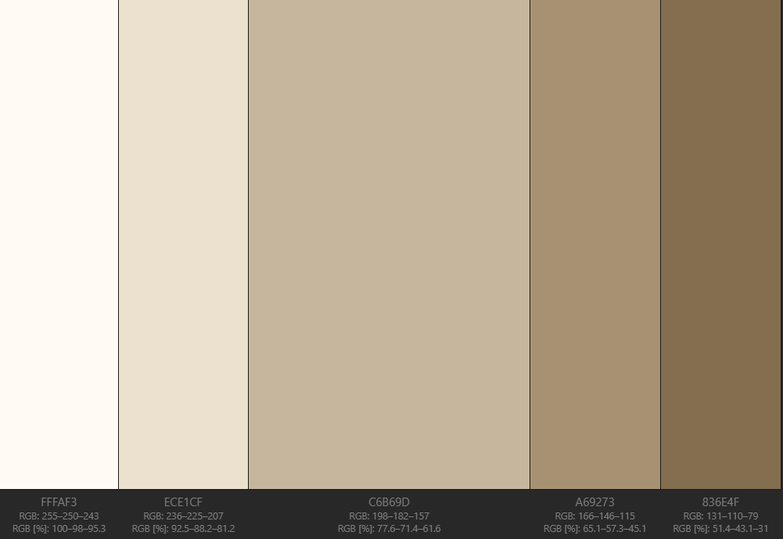

**3. Minimum Contrast for Accessibility**  
To ensure accessibility; the website will have a minimum contrast ratio of 4.5:1 for normal text and 3:1 for large text. This will help users with visuals to read the content comfortably.

**4. Front-end Development Technologies  
The front-end will utilize the following technologies:**

* HTML5: For the basic structure of the web pages.
* CSS: For styling and layout.
* JavaScript: For interactive features.
* Frameworks: Bootstrap to make the design responsive, and jQuery for easier coding.

**5. Content Management Systems (CMS)**  
A CMS will be implemented to make it easy to manage. Options include:

* WordPress: a flexible, popular choice, perfect for galleries.
* Squarespace: offers beautiful templates and is easy for artists to use.
* Wix: known for its drag-and-drop tools, making it simple for anyone to create and update pages.

**6. Back-end Development Technologies**  
**The back end will support content management and user interactions with the following technologies:**

* Node.js: for fast, server-side coding
* Express.js: makes routing and managing server tasks easier.
* Database: MySQL to store user info, artworks, and other data

**7. Metrics for Measuring Website Performance**  
**Metrics to track the website's performance will include:**

* Page Load Time: Time taken for pages to fully load.
* Bounce Rate: Percentage of visitors who leave after viewing only one page.
* User Engagement: Average time spent on the site and pages per session.
* Conversion Rate: Percentage of visitors who make a purchase or sign up
* Accessibility Score: measured with tools like Google Lighthouse to ensure everyone can use the site comfortably

**8. HTML5 Page Structure  
The HTML5 structure for every page will include the following basic components:**

**<!DOCTYPE html>**

**<html lang="en">**

**<head>**

**<meta charset="UTF-8">**

**<meta name="viewport" content="width=device-width, initial-scale=1.0">**

**<title>Echoes of art</title>**

**<link rel="stylesheet" href="styles.css">**

**<script src="script.js" defer></script>**

**</head>**

**<body>**

**<header>**

**<nav>**

**<ul>**

**<li><a href="index.html">Home</a></li>**

**<li><a href="about.html">About Us</a></li>**

**<li><a href="exhibitions.html">Exhibitions</a></li>**

**<li><a href="artists.html">Artists</a></li>**

**<li><a href="artworks.html">Artworks</a></li>**

**<li><a href="trending.html">Trending</a></li>**

**<li><a href="contact.html">Contact</a></li>**

**</ul>**

**</nav>**

**</header>**

**<main>** **<!-- Page-specific content goes here --> </main>**

**<footer>**

**<p>&copy; 2024 Echoes of art. All rights reserved </p>**

**</footer>**

**</body>**

**</html>**